Practical - 1 [Font Style Times New Roman – 16]

Aim:
Implement a function for each of following problems and count the number of steps executed/Time taken by each function on various inputs and write complexity of each function. Also draw a comparative chart. In each of the following function N will be passed by user.
- To calculate sum of 1 to N number using loop.
- To calculate sum of 1 to N number using equation.
- To calculate sum of 1 to N numbers using recursion. [Font Style Times New Roman – 12]

Code: [Font Style Times New Roman – 12, Bold, Underline]
//Add code [Font Style Times New Roman – 12]

#include <iostream>
using namespace std;
int main ()
{
// prints “Let us learn C++”↖Code: times new roman -12

cout << "Let us learn C++";
return 0;
}

Output: [Font Style Times New Roman – 12, Bold, Underline]
//Add Screenshot of Output
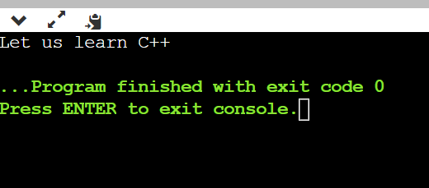

Analysis: [Font Style Times New Roman – 12, Bold, Underline]
//Add Analysis Table with minimum 5 values of input [Font Style Times New Roman – 12]

Value of N | Steps in iteration method | Steps in recursive method
5 | 7 | 15
10 | 12 | 177
15 | 17 | 1973
20 | 22 | 21891
25 | 27 | 242785

//Add Analysis Chart
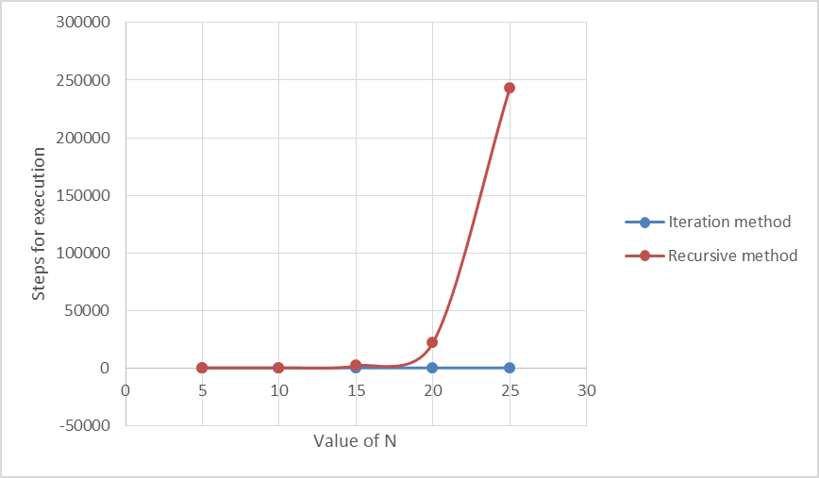
Conclusion:
//Add Conclusion with 5 to 8 lines [Font Style Times New Roman – 12]

